**Chapter 5: The Formation of Stars and Planets**

**5.1: Molecular Clouds are the Cradles of Star Formation**

**Interstellar Clouds**

* Stars/planets form from large clouds of dust and gas
  + Interstellar clouds are clouds of cool dust and gas in the space between stars
  + They have self-gravity (it is attracted to itself)
  + Also has outward gas pressure
    - If self-gravity and outward gas pressure are the same, the molecular cloud is in hydrostatic equilibrium
* Molecular clouds are the densest, coolest interstellar clouds
  + Primarily composed of hydrogen
  + They collapse under their own self gravity slowly

**Molecular-Cloud Fragmentation**

* Pockets of denser gasses accrue together in molecular clouds, forming molecular-cloud cores
  + May be hundreds to thousands of cores in a single molecular cloud collapse
  + These cores increase in size exponentially due to the inverse square law of gravity
  + The majority of the molecular cloud’s self-gravity is at the center of the cloud

**5.2: The Protostar Becomes a Star**

**Stars and Protostars**

* The inner most molecular-cloud core is called a *protostar*
  + As it collapses, gravitational energy is converted to thermal energy, heating the protostar to thousands of degrees kelvin.
  + Eventually, the protostar radiates this heat outwards.
  + Protostars are thousands of times brighter than the Sun
    - Can’t really tell though. Radiation of light in the infrared and the protostar is at the center of a molecular-cloud
    - 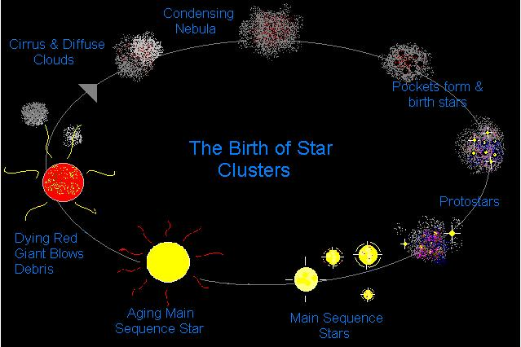Nebula: most general term for an interstellar cloud of dust/gas

**A Shifting Balance: the Evolving Protostar**

* The force pushing outward from gas is always equal to the self-gravity of the protostar, yet always changing (like a spring)
* Gravitational energy is converted to thermal energy continuously throughout this process, until it reaches a suitable temperature to “ignite”
  + Nuclear fusion of hydrogen/helium creates the star
  + Dependent on mass. Must be at least 0.08 times the mass of the Sun to become a proper star (10M Kelvin center)
  + If not this mass, protostar becomes a brown dwarf

**5.3: Planets Form in a Disk around the Protostar**

**Convergence of Evidence**

* To figure out how our solar system formed, we look at meteorites that fell to the Earth back when the solar system was young.
  + They indicate that planets formed from accreting material over time
  + Additionally, it was found that the early solar system was flat, and everything in it orbited in the same direction
  + This led to the idea of an accretion disk around the Sun, which accounted for the accumulation of materials to form planets

**The Collapsing Cloud and Angular Momentum**

* The accretion disk around forming stars can be attributed to *angular momentum*
  + AM depends on 3 things:
    - How fast the object is rotating
    - The mass of the object
    - How the mass of the object is distributed relative to the spin axis
  + Conservative angular momentum: this AM must remain the same in the absence of an outside force

**The Formation of an Accretion Disk**

* Excess angular momentum can be attributed to the extremely large accretion disk formed by the molecular-clouds excess dust and gas
  + 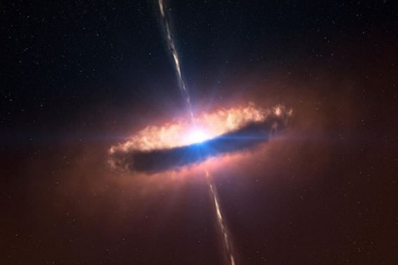This disk is flat due to the gravitational pull of various dust formations canceling pulling each other together to a line

**Creation of Larger Objects**

* In the accretion disk, clumps of dust begin to stick together slowly, forming larger clumps
  + Eventually these clumps get large enough so that their own gravity pulls other particles towards it, growing to the size of a *planetesimal*
  + Planetesimals continue to grow and eventually become planets

**5.4: The Inner and Outer Disk have Different Compositions**

**Rock, Metal, and Ice**

* Certain materials in the disk are generally located at specific areas
  + Closest to the protostar (the hottest areas) are refractory materials such as metals and rocks
  + Next, in the middle range, are things such as water ice (solid water) and other solid forms of volatile materials
  + In the outer most, and coldest, areas are the volatile gases such as methane and ammonia
* *Planetary migration*
  + Gravitational scattering or interactions with gas in the protoplanetary disk can force some planets to end up far from where they formed

**Atmosphere around Solid Planets**

* Planets have a limited amount of time to accumulate gases in the accretion disk before it dissipates
  + *Primary Atmosphere:*
    - The gas (usually hydrogren/helium) captured by a planet when it is initially formed
  + *Secondary Atmosphere*
    - Forms later in the life of a planet, sometimes after the primary atmosphere has dissipated due to lack of strong gravity of planet
    - Volcanism is key to forming this
    - *Comets* also (rich with minerals).
      * Icy planetesimals that survive planetary accretion

**5.5: A Case Study**

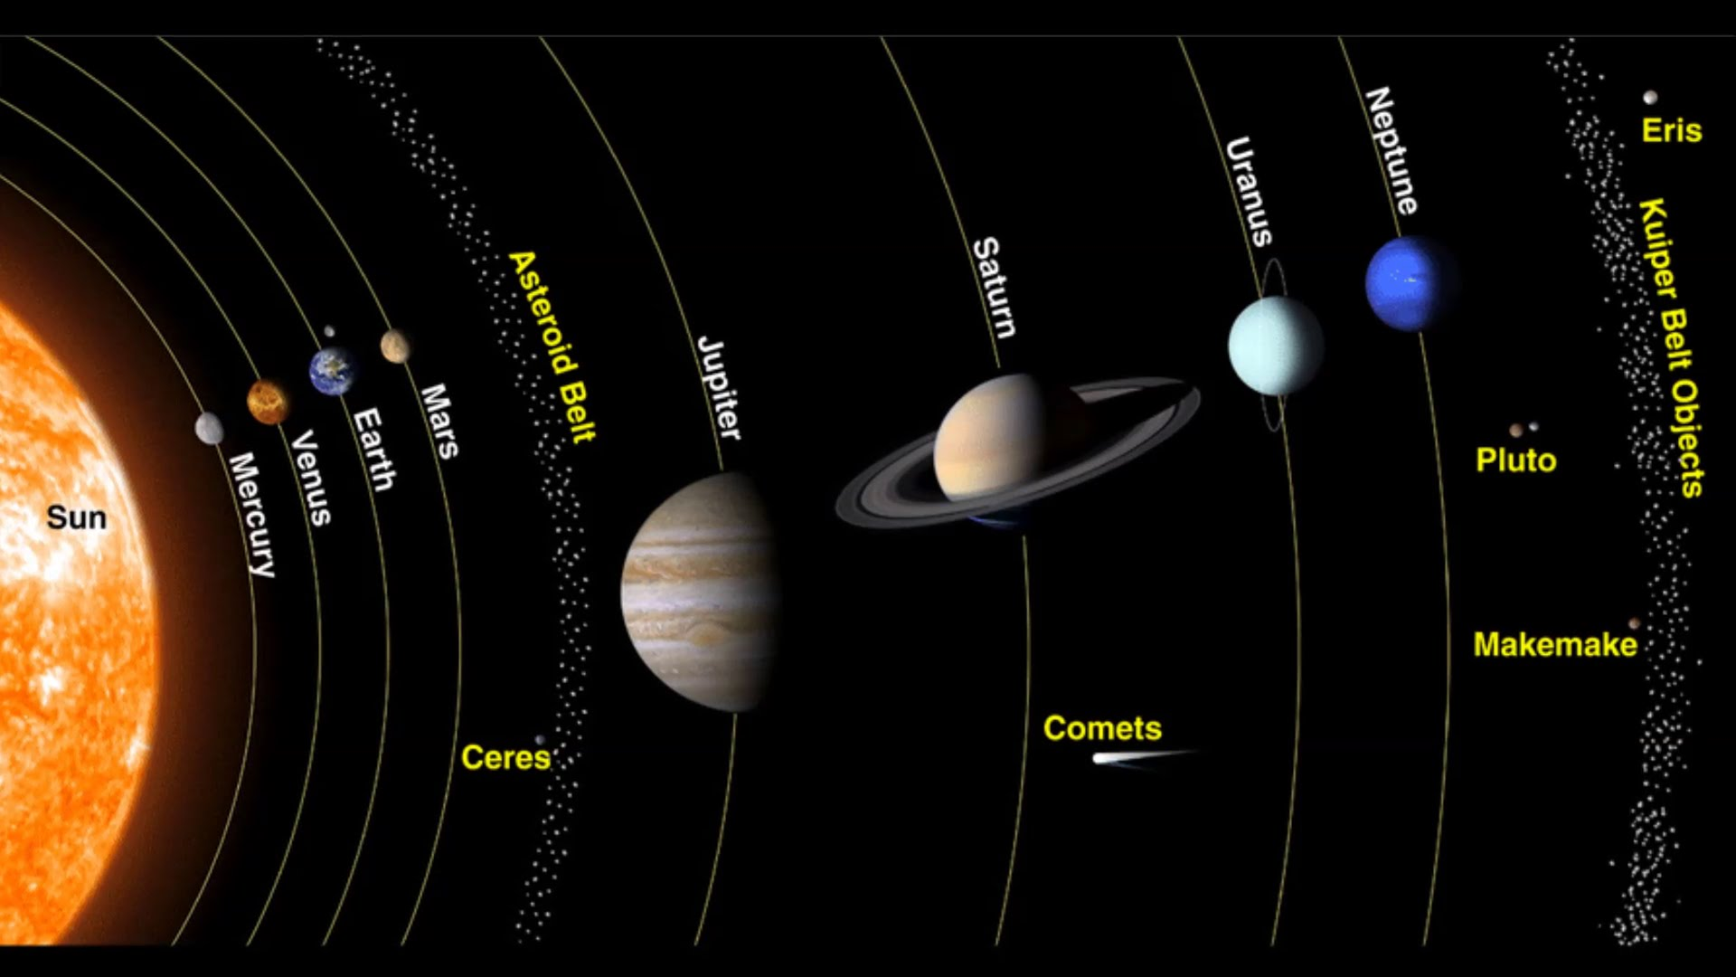 **The Solar System**

* Terrestrial planets:
  + Mercury
  + Venus
  + Earth
  + Mars
* Giant planets
  + Jupiter
  + Saturn
  + Uranus
  + Neptune
* Dwarf giants
  + Pluto
  + Ceres
  + Eris
  + Makemake
* Asteroids
  + Asteroid belt
  + Kuiper belt

**5.6: Planetary Systems are Common**

**The Search for Extrasolar Planets**

* Many methods used to discover new planets
  + Radial Velocity Method:
    - 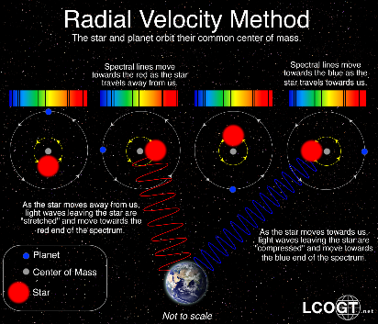The Doppler effect is the main factor in this method, examining light waves from the planets and their stars
    - As an object moves towards us, their light waves appear “crowded” together in front of the object, with shorter wavelengths (**blueshifted)**
    - The reverse is true for an object moving away from you (**redshifted)**
    - This only works if an object is moving towards or away from you
    - Tells us the planets mass and its distance to its parent star
  + Transit Method
    - 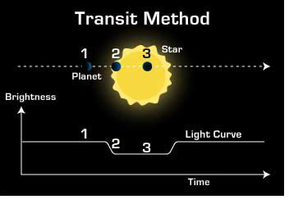When a planet moves in front of its parent star, the light emitted from that star that we can see diminishes slightly
    - This provides us with the size of the planet
  + Gravitational Lensing
    - When a planet passes in front of its star, the light of the star brightens around the edge of the planet
    - Gives approximations for size and mass
  + Astrometry
    - Precisely measuring the position of a star in the sky when viewed from above the plane of the planets in the solar system.
  + Direct Imaging
    - Taking a picture of the planet directly
    - Technically difficult due to relative brightness of star to planet
    - Can be achieved with space telescopes

**Other Planets**

* Some of the first planets discovered by astronomers were hot Jupiters
  + Jupiter sized gas giants in a close circular orbit around a star
* Most planets discovered now are closer in size to Neptune, or between Earth and Neptune if the discovered planet is terrestrial